Experiment: Implementation of Logistic Regression (LR) Algorithm in Python
Aim
To implement the Logistic Regression (LR) algorithm in Python and classify the data using the Iris dataset.
Theory
Logistic Regression is a supervised machine learning algorithm used for classification problems. It predicts the probability that an input belongs to a particular class. It is widely used for binary and multi-class classification.
Procedure
- Import the required Python libraries.
- Load the Iris dataset.
- Split the dataset into training and testing sets.
- Create the Logistic Regression model.
- Train the model using the training dataset.
- Predict the class labels for the test dataset.
- Display the confusion matrix.
- Calculate the accuracy of the model.
- Display the actual and predicted values.
Python Program
from sklearn.datasets import load_iris
from sklearn.model_selection import train_test_split
from sklearn.linear_model import LogisticRegression
from sklearn.metrics import confusion_matrix, accuracy_score
# Load Iris Dataset
iris = load_iris()
X = iris.data
y = iris.target
# Split dataset into training and testing
X_train, X_test, y_train, y_test = train_test_split(
X, y, test_size=0.3, random_state=1
)
# Create Logistic Regression model
model = LogisticRegression(max_iter=200)
# Train the model
model.fit(X_train, y_train)
# Predict
y_pred = model.predict(X_test)
# Confusion Matrix
cm = confusion_matrix(y_test, y_pred)
# Accuracy
accuracy = accuracy_score(y_test, y_pred)
# Display Results
print("Confusion Matrix:")
print(cm)
print("\nActual Values:")
print(y_test)
print("\nPredicted Values:")
print(y_pred)
print("\nAccuracy:", accuracy)

Output
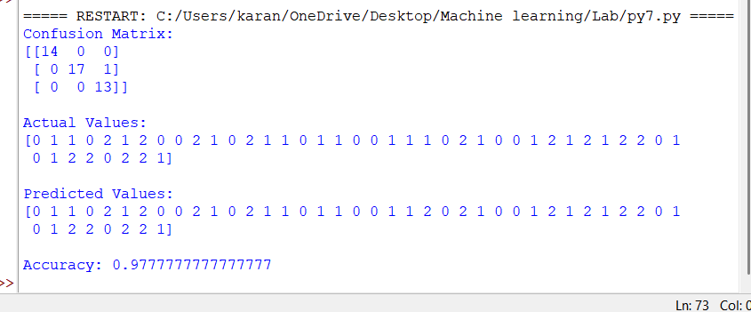
Result
The Logistic Regression (LR) algorithm was successfully implemented in Python. The model was trained and tested using the Iris dataset, and its performance was evaluated using the confusion matrix and accuracy.

